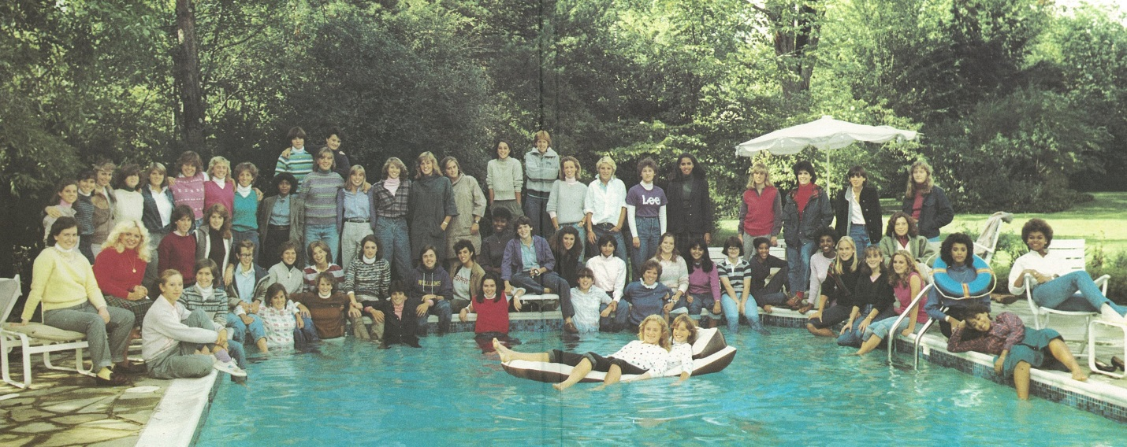

The Class of 1984

2014 Alumnae Achievement Award

For the first time in the history of the Hathaway Brown School Alumnae Awards, the Alumnae Achievement Award is being presented to an entire class. The Class of 1984 is 63 women strong. Professionally, they represent various industries including among others law, healthcare, and business/finance. They hold job titles or positions such as owner, director, partner, CEO, doctor, entrepreneur and homemaker, to name a few. This group’s commitment to the community is impressive, from their involvement with nonprofit organizations to their philanthropic endeavors.
The dedication of the Class of 1984 to HB is extraordinary. Several members have been or now are represented on the HB Board of Trustees, Head’s Council, Alumnae Council and advisory committees, and they’ve had high participation rates for alumnae gatherings and local and regional school events.. Above all, the class is a model for the rest of the alumnae community, as these HB women have stayed in touch and connected through the years. They serve as a wonderful and powerful example of the strength of the HB sisterhood.

