A Glimpse at Judson Park

Caitlin Matsen

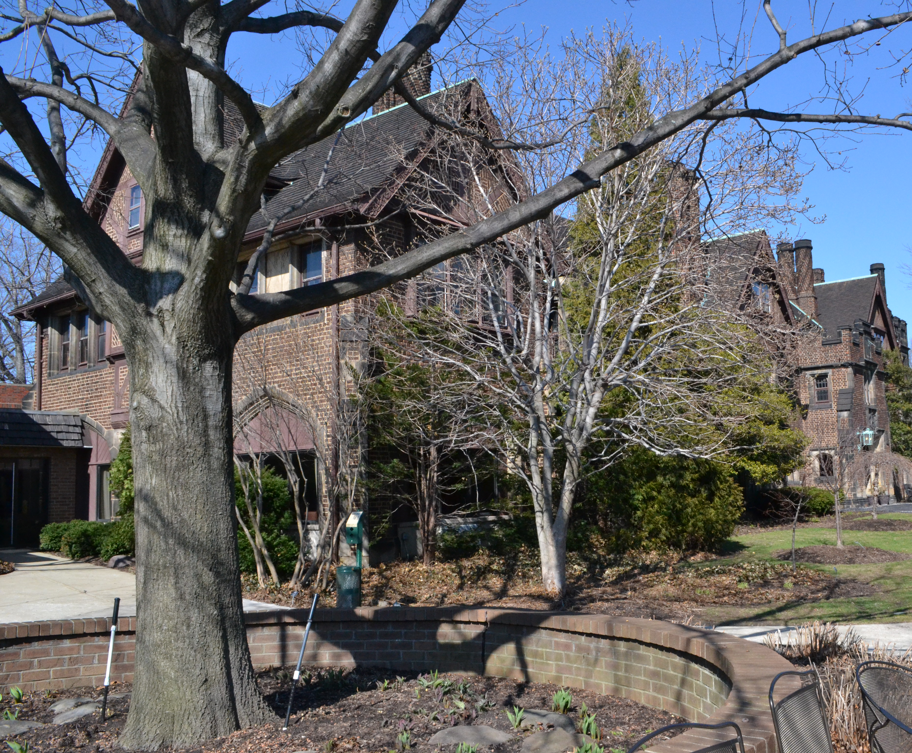

Service Learning Capstone Project

April 22, 2014

Judson is a non-profit organization whose mission is to “provide programs and living options for individuals taking responsibility for their successful aging” (The Judson Volunteer Handbook, 3). Successful aging can be achieved through a continuation of exercise and maintaining health, while also remaining mentally active through the arts, music and other crafts, as well as continuing to interact with those of various generations.
Judson at University Circle was founded on January 9, 1906 as a “nonprofit, interdenominational agency” called the Baptist Home of Northern Ohio (Judson Retirement Community, 1). Judson Park and Judson Manor were constructed as separate facilities that share the purpose of providing independent and assisted care and space for those who have ceased working and have retired. The idea for creating a space like Judson arose on November 1, 1904 from six members of the Women’s Social Bible Class of the Euclid Avenue Baptist Church. This group bought land on Prospect Avenue and Cedar Road, but eventually bought Warren G. Bicknell’s estate, which consisted of seven acres. This estate has received additions over the years, including the 10-story Jordan Gardner apartment complex that was built in 1973 and later called Judson Park after the Baptist missionary Adoniram Judson. Judson Manor was eventually added, but originally served as the Wade Park Manor hotel and was later bought by the Christian Residences Foundation to serve as a retirement home. This group eventually joined the property with Judson Park to create Judson Retirement Community. The Bruening Health Center was created in 1991 and contains three floors occupied by nurses and aides, the Parkhurst Pool, and Physical or Occupational Therapy services. Another important addition to Judson was the creation of The Mansion Courts, which was originally the Bicknell mansion. This property contains seven Independent Living suites and is near Judson Park, thus allowing residents access to services from both properties. The Mansion Courts won the 1998 Preservation Award due to its renovations and modifications made by residents. Judson also altered its name in 2003 from Judson Retirement Community to Judson at University Circle. Judson has existed for over a 100 years and continues to serve the Cleveland community with the help of volunteers, trained professionals, its Board of Trustees, and the support of residents and the community (The Judson Volunteer Handbook, 2).
Judson holds the philosophy of “Smart Living,” which includes aspects such as, “planning and taking charge of one’s life”, “healthy choices that fit any lifestyle,” “both a destination and a journey for all of us,” “a dynamic proactive approach to life,” and “combining the reality of a person’s situation with opportunity and creative solutions” (The Judson Volunteer Handbook, 1). This philosophy coincides with Judson’s mission statement and their purpose to help residents achieve independence, assist in their quality of life, and provide care and support to residents of various socio-economic backgrounds. Judson is the first facility in Northeast Ohio to be registered in The Eden Alternative, which is a philosophy aimed at changing the culture and atmosphere within retirement and nursing communities. The philosophy was created by William Thomas, who is a physician from New York, and focuses on creating a better quality of life for those living and working in nursing homes. The philosophy involves improving the resident’s and employees’ lives by having animals live in the facility and having children visit frequently, rather than random or sporadic visits. This philosophy also strives to create a familial, or close relationship, between staff and residents in order to create strong bonds and make the facility feel more like a home and better place (The Judson Volunteer Handbook, 28).
Judson is able to serve its residents and serve its purpose through various programs, such as its award-winning Health & Wellness programs, which strives to keep residents active and independent. The program focuses on six aspects of life, including: social, spiritual, emotional, intellectual, physical, and occupational factors. Programs include: aerobics, power walking, massage therapy, strength training, personal training, Tai-Chi, yoga, Reiki, and Healing Touch ("Judson Park Wellness Programs", 1-2). Programs such as these help provide residents with positive aging and provide a service to the Cleveland community.
The idea of successful aging has been the subject of various debates and has become a relevant topic as numerous societies are facing economic and social impacts from an increasingly older population. These countries include, Japan, Germany, Italy, and the United States. Countries with the quickest rate of change in population age include, Iran, Vietnam, Mexico, India, and South Korea. Helen Lavretsky, a geriatric psychiatrist and professor in the department of psychiatry at UCLA, states that the predictable outcomes of this population change are a smaller working force and a focus on health care. Lavretsky notes that aging can have many positive aspects, as humans tend to gain experience, knowledge, judgment, and more wisdom; however, aging often brings the decline of mental and physical abilities. She alternatively says that the National Institute of Aging states that about 87% of humans at age 65 or older are generally healthy. Lavretsky, believes that continued intellectual stimulation and various other factors, including remaining socially connected and physically active, help achieve the idea of successful aging. She cites examples of well-known people who remained active in their old age, such as Leo Tolstoy who learned to ride a bike at the age of 67 or Robert Frost who continued to write poems. She states that these lifestyle choices and a positive outlook will help mental health and ultimately dealing with the aging process, while remaining an active part of the community (Lavrestsky, 1-2).

Bibliography:

"Judson Retirement Community." The Encyclopedia of Cleveland History. Case Western Reserve Univ., 29 Aug 2006. Web. 14 April
2014. http://ech.case.edu/cgi/article.pl?id=JRC

"Judson Park Wellness Programs." Judson Smart Living. Judson Services, Inc., n.d. Web. 14 April 2014.
http://www.judsonsmartliving.org/judson-park/wellness-programs/

Lavretsky, Helen. "Successful Aging: Strategies to Help Maintain and Nurture a Healthy Brain." Psychiatric Times. N.p., 20 May 2013. Web. 05 Dec. 2013.
http://www.psychiatrictimes.com/geriatric-psychiatry/successful-aging-strategies-help-maintain-and-nurture-healthy-brain

The Judson Volunteer Handbook Revised. Ohio: Cleveland, 2013. Print.

