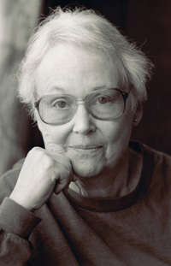

Janet Nutt Lembke 1949

2014 Distinguished Alumna Award

Janet Lembke was a prolific author, scholar, and translator. Her books include poetry, literary translations, and collections of essays on the natural world. In 2005, she received a grant from the National Endowment for the Arts to translate Virgil’s Georgics, a poem on farming. She also was a certified Virginia Master Gardener. At the time of her death in 2013, she had just published the last two of her 20 books and was working on yet another, a memoir: I Married an Arsonist.

Janet regularly attended HB’s alumnae gathering in Charlottesville, Va., and she enjoyed this annual opportunity to reconnect with HB administrators and fellow alumnae in the Virginia area.

